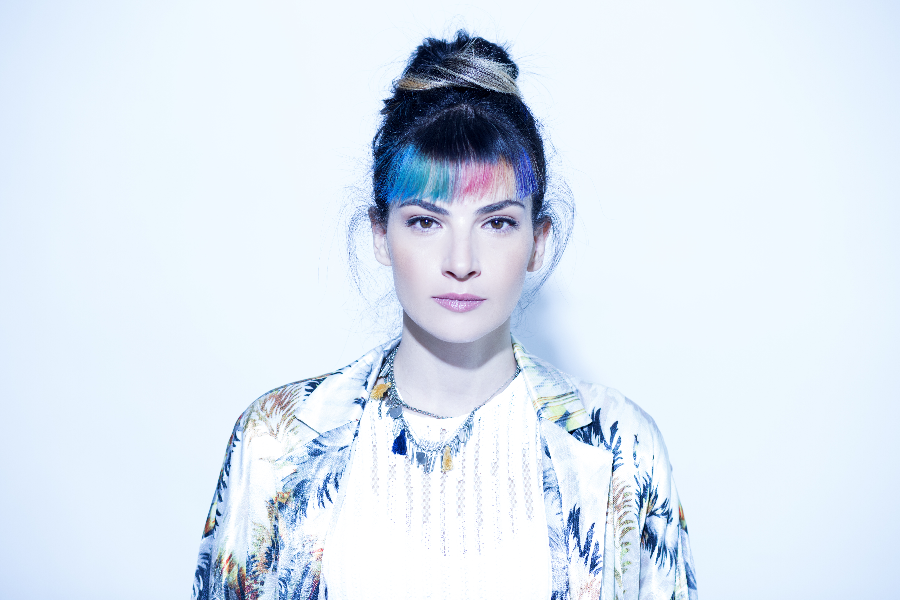

Dorine Levy is a Canadian singer, songwriter, composer and music producer
Underwater her debut album was released in 2014 written and produced by herself
Including highlights tracks:

“There for Me “
- Premiered - MTV Boutique playlist alongside Tegan and Sara & Disclosure
- Featured - FOREVER 21 campaign
- Featured - QUICKSILVER campaign
- Featured - BBC 6 by Tom Robinson

“ Cow Boy Fest “
- Featured - SUECOMMA BONNIE campaign (3 times)
“ Lenyrose “
- Premiered - WONDERLAND MAGAZINE (over a 1000 shares in 2 days)
- Premiered - MTV Boutique playlist
- Featured - SHORTLIST track of the Day
- Featured - INDIE SHUFFLE
- Featured - IT’S ALL INDIE track of the Day

With The release of “Underwater” Dorine Played Hundreds of live shows including highligts:

- SXSW 2013 AUSTIN
- CMJ 2013 NY
- INDIE WEEK FEST TORONTO
- MAD MUSIC FESTIVAL 2013 TLV
- TUNE IN TLV MUSIC FESTIVAL 2013, 2014, 2015 TLV
- PLATFORM MUSIC FESTIVAL 2013 YAFO-TLV
- NOUVELLE PRAGUE 2013 PRAGUE
- CANADIAN MUSIC WEEK 2014 TORONTO
- SOUND CITY 2014 LIVERPOOL,
- JAMROCK 2014 ZAMBERG
- CULTURE COLLIDE 2014 LA & SAN FRANSISCO
- CMJ 2014 NY

Website
Facebook page
Youtube
SoundCloud
info@dorinelevy.com

